Geo Tracking / Geo fencing

Requirements:

* PostgreSQL (Version: 16.3, Download Link: <https://www.postgresql.org/download/>, Referential video to download : <https://youtu.be/LhKj-_-CCfY?si=-aR45UsAVtx7k13v>)
* QGIS (Version: 3.36.3, Download link: <https://www.qgis.org/en/site/forusers/download.html>, Referential video to download: <https://youtu.be/fgS1eVPPBiE?si=_VpmjeoFT-kVz7Ud> )
* Python (Version: 3.12.4, Download link: <https://www.python.org/downloads/>)
* Visual Studio Code: (Version: 1.90, Download link: <https://code.visualstudio.com/>, Referential video to download: <https://youtu.be/t2_Q2BRzeEE?si=UPW7fMIb9eO2KwhE> {Watch from 8:01 to 12:38 minutes}

PostgreSQL:

PostgreSQL is a powerful, open-source object-relational database system. We have used this Open source to store the location (latitude and longitude) of a user, timestamp and to store geometric data.

QGIS:

QGIS is a free and open-source Geographical Information System.   
Once we have done the installation and set up PostgreSQL, we need to connect the database to our QGIS, hence we need to go to Open Data Source Manager and check for PostgreSQL. After we find PostgreSQL, we need to right click on it and click on new connection then we find the below interface 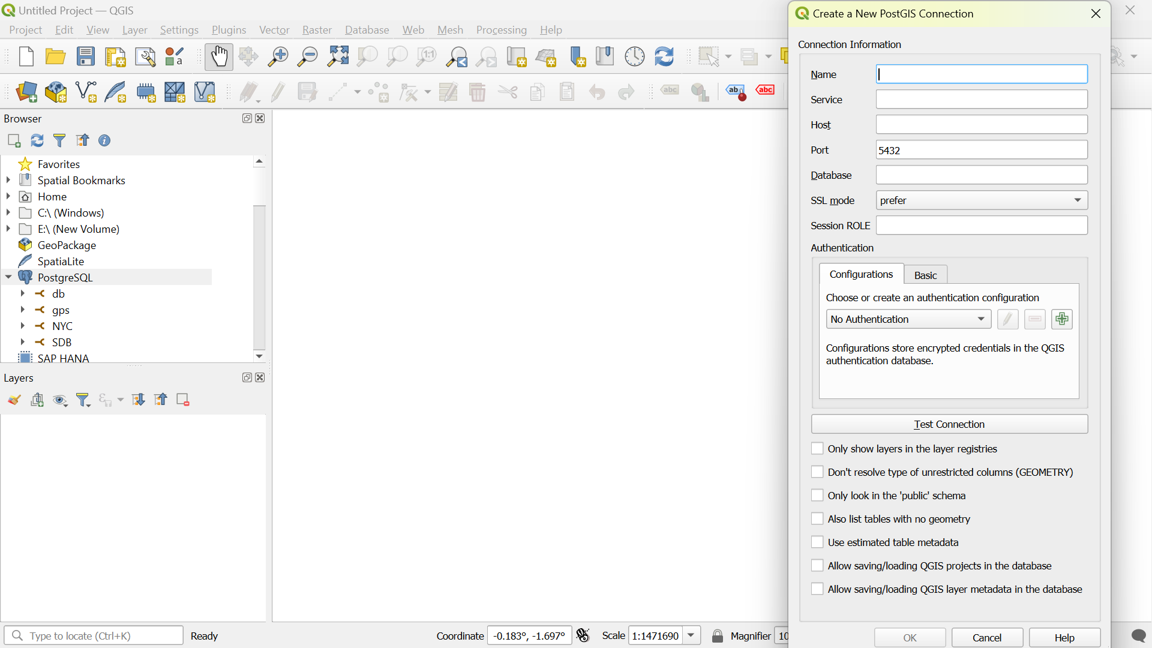

After this we can give any to name in name section, service should be kept blank host name should be given which in my case is localhost, then database name to which the QGIS must be connect (i.e., the name of the database in PostgreSQL). Rest should not be changed.

For Authentication Section we must click on Basic and give user name (Owner name) which in most of the case will be postgres. Password should also be given here. Then we need to click on Test Connection. After all this we need to click on ok so that connection will be successful.

Once the process is done then the data stored in PostgreSQL can be visualized in QGIS.

To find the routes to travel between two points we need to use Rest API called Open route Server (ORS). We have to check for Plugin in QGIS and install ORS tools. Then we need to sign in to it and generate a key/ token which can be used to find fastest, shortest and recommended routes. To find routes we need to go web icon in QGIS and click on ORS tools (ctrl + R) then we need to select two coordinates (i.e., Source and Destination) and find the required routes.

For getting Different icons for we need to right click on the layer which we retrieved from the database, click on properties and name according to user_id. After this we need to go to symbology and click on ‘+’ mark which will create the new marker, then we need to change the symbol layer type to SVG Marker and we can use the useful design.

Python:

To Connect Python with our Database use module psycopg2. At first, we need to install this module by typing “pip install psycopg2” in your terminal. Now we can use my code to execute the task.